Final Term
12. Number system-> Binary to Decimal and Decimal to Binary
Binary -> 2 base ( 1101₂ ) Decimal -> 10 base ( 13₁₀ )
Hexadecimal -> 16 base ( 62_{C} ) Octal -> 8 base ( 154₈ )
Binary to Decimal convert:
Find the decimal value of 111001₂ :
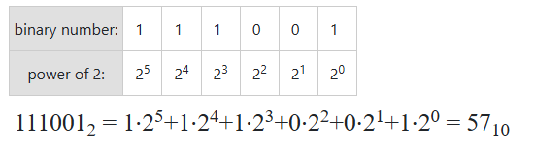

Decimal to Binary convert:
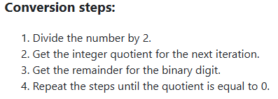
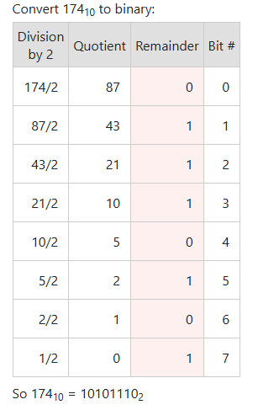
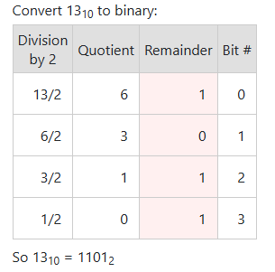
Find the binary value of 13₁₀ :

*** Down -> top (নিচ থেকে উপরের দিকে সংখ্যা সাজানো)

Floating Number Decimal to Binary convert:
Top -> Down

13. Benefits of High level Language (HLL)
- Closer to Natural Languages
  - C++
  - FORTRAN scientific computation
  - COBOL business data processing
- Increased Programmer productivity
  - Small and concise code
  - Easy and Quick Programming
- Independent of Hardware Platform
  - Compiler converts HLL code to target code
14. Define Instruction Set Architecture (ISA) with example
- Different CPUs implement different sets of instructions. The set of instructions a particular CPU implements is an Instruction Set Architecture (ISA).
  - Examples: Intel 80x86 (Pentium 4), IBM/Motorola PowerPC (Macintosh), MIPS, Intel IA64, ...
15. Explain Reduced Instruction Set Computing.
RISC (Reduced Instruction Set Computer) is a CPU design that uses a small number of simple and fast instructions to improve performance and efficiency.
RISC philosophy (John Cocke IBM, David A. Patterson, John L. Hennessy, 1980s) – Reduced Instruction Set Computing
  - Keep the instruction set small and simple, makes it easier to build fast hardware.
Features of RISC:
  - fixed instruction lengths
  - load-store instruction sets
  - limited addressing modes
  - limited operations

16. Define Microprocessor without Interlocked Pipeline Stages (MIPS) Architecture. Why MIPS instead of Intel 80x86?
MIPS – semiconductor company that built one of the first commercial RISC architectures.
Instead of Intel 80x86:
  - MIPS is simple, elegant. Don’t want to get bogged down in gritty details.
  - MIPS widely used in embedded apps, x86 little used in embedded, and more embedded computers than PCs
  - NEC, Silicon Graphics, Nintendo, Sony etc.

17. Assembly Variables : Registers
a. Question: Drawback: Since registers are in hardware, there are a predetermined number of them
Solution: MIPS code must be very carefully put together to efficiently use registers.
Why Is This a Drawback?
1. Limited Number of Registers
2. Performance May Decrease: More memory access → More load/store instructions → Slower execution
3. Less Flexibility
b. Question: 32 registers in MIPS. Why 32?
Smaller is faster
In MIPS architecture, there are 32 general-purpose registers. This design choice was made for a balance between performance, hardware cost, and simplicity.
Main reasons for choosing 32 registers:
1. Efficient Instruction Encoding
2. Good Balance Between Cost and Performance
3. Supports Compiler Optimization

18. MIPS Assembly Language
Arithmetic -> all Data transfer -> load, store
Logical -> and, or Conditional branch -> all
Unconditional jump -> jump, jump register
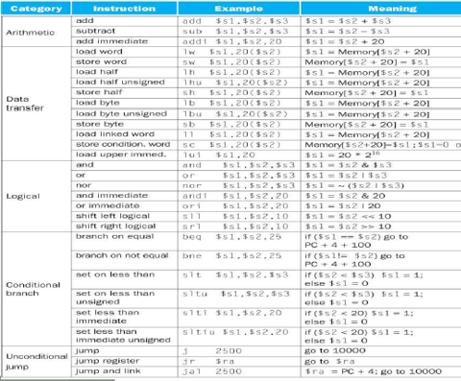

19. Format (R,I,J)
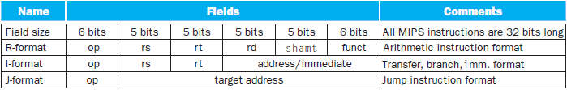
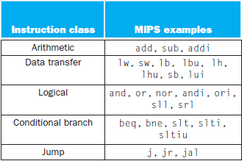

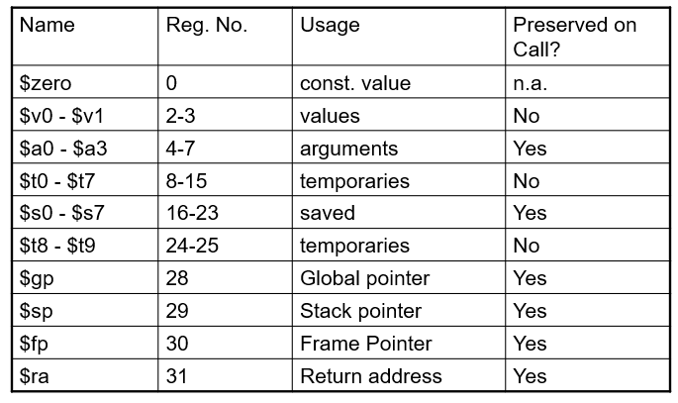
20. MIPS register

21. Assembly Variable : Registers
- Registers are numbered from 0 to 31
- Each register can be referred to by number or name
- Number references:
$0, $1, $2, … $30, $31

*** By convention, each register also has a name to make it easier to code
- For now:
$16 - $23 $s0 - $s7
(correspond to C variables)
$8 - $15 $t0 - $t7

22. C , Java variables vs registers
Variables (C/Java) | Registers
1. Declared by programmer | 1. Built into CPU hardware
2. Stored mainly in RAM | 2. Stored inside CPU
3. Slower access | 3. Very fast access
4. Can create many variables | 4. Limited number (e.g., 32 in MIPS)
5. Example: int fahr, celsius;  Char a,b,c,d,e; | 5. Example: register -> $ (dollar sign)

23. Assembly Instruction Short note:
- In assembly language, each statement (called an Instruction), executes exactly one of a short list of simple commands
- Unlike in C (and most other High Level Languages), each line of assembly code contains at most 1 instruction
- Instructions are related to operations (=, +, -, *, /) in C or Java
24. Addition and Subtraction of Integers:
- Addition in Assembly
  - Example: add $s0, $s1,$s2 (in MIPS)
Equivalent to: a = b + c (in C)
where MIPS registers $s0, $s1, $s2 are associated with C variables a, b, c
- Subtraction in Assembly
  - Example: sub $s3, $s4,$s5 (in MIPS)
Equivalent to: d = e - f (in C)
where MIPS registers $s3, $s4, $s5 are associated with C variables d, e, f
25. Add Instruction:
- Instructions, like registers and words of data, are 32 bits long
- Arithmetic Instruction Format (R format):
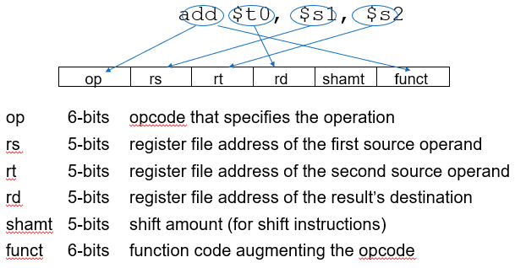

26. R-format example -> Machine code convert.
i. Assembly to Binary ii. Binary to Assembly
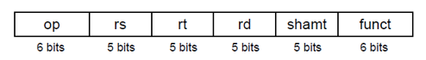

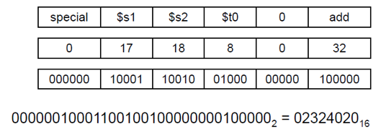
Question: add $t0, $s1, $s2

27. Addition and Subtraction of Integers
- How do the following C statement?
a = b + c + d - e;
- Break into multiple instructions
add $t0, $s1, $s2 # temp = b + c
add $t0, $t0, $s3 # temp = temp + d
sub $s0, $t0, $s4 # a = temp - e
- Notice: A single line of C may break up into several lines of MIPS.
- Notice: Everything after the hash mark on each line is ignored (comments)

28. Addition and Subtraction of Integers
- How do we do this?
f = (g + h) - (i + j);
- Use intermediate temporary register
add $t0,$s1,$s2 # temp = g + h
add $t1,$s3,$s4 # temp = i + j
sub $s0,$t0,$t1 # f=(g+h)-(i+j)

29. Register Zero
- One particular immediate, the number zero (0), appears very often in code.
- So we define register zero ($0 or $zero) to always have the value 0; eg
add $s0, $s1, $zero (in MIPS)
f = g (in C)
where MIPS registers $s0, $s1 are associated with C variables f, g
- defined in hardware, so an instruction
add $zero, $zero, $s0

30. Immediates
- Immediates are numerical constants.
- Add Immediate:
add $s0, $s1, 10 (in MIPS)
f = g + 10 (in C)
where MIPS registers $s0, $s1 are associated with C variables f, g

*** 27, 28, 29, 30 -> simple code segment দেওয়া থাকবে Assembly language convert করতে হবে .

